4.4 Design of Roof Slab:
The imposed loads on flat roofs, sloping roofs and curved roofs, due to use or occupancy of the building and the geometry of the types of roofs are given in Table -2 of IS:875(Part 2)-1987.
In our case, the imposed load on the roof slab is taken as 2 KN/m² because the access is provided to the roofs. [It is given in page. 14, table – 2, clauses 4.1 of IS 875(part -2) – 1987]
For designation point of view, the roof slabs are named S1, S2, S3, and S4. Since each slab panel in our layout has unique dimensions (2.8m x 3.4m, 3.1m x 3.4m, 2.8m x 3.28m, and 3.1m x 3.28m), there are no symmetrical groups, and each will be designed individually as shown in the figure below. The slab thickness is taken as 100mm.
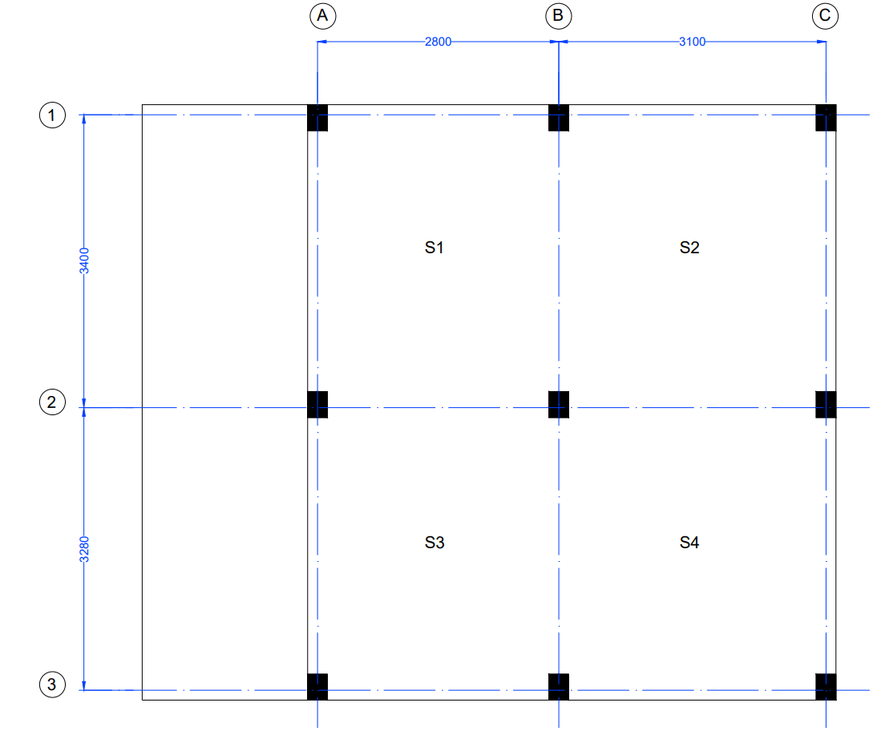
Figure 4.1: Slab.

DESIGN OF SLAB [S1]:

As per Ratio,
L_{X} = 2800 mm
L_{Y} = 3400 mm

$\frac{Ly}{Lx}$ = $\frac{3400}{2800}$ =$1.21<2$

So the slab should be design as two way slab

Assuming the Depth:
Overall depth of the slab = d_{o} = 100 mm
Diameter of the bar in Shorter Span directions = 8 mm
Diameter of the bar in Longer directions = 8 mm
Clear cover = 15 mm
Code limits:

As per IS 456-2000 Overall depth of the slab should be greater of the following

- d_{o} > 100 mm
So it is satisfied.
Diameter of the bar:

The diameter of reinforcing bar shall not exceed one eight of the total thickness of the slab witch is given in page No.48 of IS - 456-2000 in article 26.5.2.2.

Maximum diameter of the bar =$\frac{1}{8}$ d_{o}
=$\frac{1}{8}$ x 100
= 12.5 mm > 8 mm

Maximum Dia of the bar > selected Dia bar
*So let us adopt 8mm dia bar

Effective depth:
d _{(short)} = 100 - 15 - $\frac{8}{2}$ = 81 mm
d _{(longer)} = 100 - 15 - 8 - $\frac{8}{2}$ = 73 mm

EFFECTIVE LENGTH:
Shorter span:
[ Given in page No.34 of IS - 456-2000 in article 22.2(a).]
It should be least of the following
(Clear Span= 2800-230= 2570mm)
- Clear span + Half of the bearing on either side of the slab
[Bearing = 230mm]
= $\frac{230}{2}$ + 2570 + $\frac{230}{2}$
= 2800 mm
- Clear span + Effective Depth
= 2570 + 81
= 2651 mm
*So take Effective length = 2651mm
Longer span:
[ Given in page No.34 of IS - 456-2000 in article 22.2(a).]
It should be least of the following
(Clear Span= 3400-230= 3170mm)
- Clear span + Half of the bearing on either side of the slab
[Bearing = 230 mm]
= $\frac{230}{2}$ + 3170 + $\frac{230}{2}$
= 3400 mm
- Clear span + Effective Depth
= 3170 + 73
= 3243 mm
*So take Effective length = 3243 mm

LOADS ON THE SLAB:
As per IS – 875 (Part – 2) – 1987, the imposed loads on the roof slab is taken as 2 KN /m² where the access is provided to the roofs.
[It is given in page. 14, table – 2, cause 1(a) of IS 875(part -2) – 1987]
Self weight of the slab = 1 x 1 x 0.100 x 25
= 2.5 KN/m²
Weight of weathering course = 1 KN/m²
Imposed load = 2 KN/m²

Total Load = 5.5 KN/m²
______________________________________
Now,
Factored load = 1.5 x 5.5 = 8.25 KN/m²
FACTORED BENDING MOMENTS:
$M_{x}= ∝_{x} W l_{x}^{2}$
$M_{y}= ∝_{y} W l_{x}^{2}$
The value of $∝_{x}$ and $∝_{y}$ are given in table -26 of the IS 456- 2000 in page.no.91. This values are depends on type of panel and moment consideration.
$\frac{Ly}{Lx}$ = $\frac{3243}{2651}$ =1.2233 $≅$ 1.22
$∝_{x}$= (-ve) 0.0487 & (+ve) 0.0367
$∝_{y}$= (-ve) 0.037 & (+ve) 0.028
$M_{ux}$ (+ve ) = 0.0367 x 8.25 x (2.651)² = 2.12 KN-m
$M_{ux}$ (-ve ) = 0.0487 x 8.25 x (2.651) ² = 2.82 KN-m
$M_{uy}$ (+ve ) = 0.028 x 8.25 x (2.651)² = 1.62 KN-m
$M_{uy}$ (-ve ) = 0.037 x 8.25 x (2.651)² = 2.14 KN-m

CHECK FOR DEPTH:

M_{u} = M_{u’lim}
$$M_{u} = 0.36 \frac{x_{u max}}{d} (1 - 0.42 \frac{x_{u max}}{d}) bd^{2} f_{ck}$$
For 500 grade steel, $x_{u max}$ = 0.46d which is given in page No.70 of IS - 456-2000 in article38.1.] Here maximum bending moment is considered to check the thickness.
$$2.823×{10}^{6} = 0.36 \frac{0.46d}{d} (1 - 0.42 \frac{0.46d}{d} ) 1000×d^{2} ×20$$
$d_{(required)}$ = 32.50 mm
$d_{(required)}$ < $d_{(provided)}$
So the section is safe in bending.
AREA OF REINFORCEMENT IN SLAB (A_{st}):
$+ve$ Reinforcement for shorter span:
$$M_{ux}(+ve) = 0.87 f_{y} A_{st} d (1- \frac{f_{y}A_{st} }{bd f_{ck}})$$
$$2.12 ×{10}^{6} = 0.87 × 500× A_{st}×81 (1- \frac{500×A_{st} }{1000×81× 20})$$
$$A_{st}=61.32{ mm}^{2}$$
Minimum Reinforcement:
Code limits:

As per IS 456-2000, the minimum area of steel in slab should be provided 0.12% of gross area for HYSD bars. [ It is given in page No.48 of IS - 456-2000 in article 26.5.2.1.]
$$A_{st (minimum)}=0.12\% gross area$$
$$A_{st (minimum)}=\frac{0.12}{100}×1000×100=120{ mm}^{2}$$
$$A_{st(required)}<A_{st (minimum)}$$
So provide $A_{st }$minimum…,

Spacing:

It should be lesser of the following
- $S=\frac{a_{st}}{A_{st}}×1000$ $=\frac{50.26}{120}×1000=418.83 mm$, where ($a_{st}=\frac{π}{4}×8^{2}=50.26)$
- $S=3d=3×81=243$
- $S=300mm$
Let us provide 8mm diameter HYSD bars at 240mm c/c. [$A_{st(provided)}=209.41 {mm}^{2}$]
$-ve$ Reinforcement for shorter span:
$$M_{ux}(-ve) = 0.87 f_{y} A_{st} d (1- \frac{f_{y}A_{st} }{bd f_{ck}})$$
$$2.82×{10}^{6} = 0.87 × 500× A_{st}×81 (1- \frac{500×A_{st} }{1000×81× 20})$$
$$A_{st}=82.11{ mm}^{2}$$
$$A_{st(required)}<A_{st (minimum)}$$
So provide $A_{st }$minimum…,
Spacing:

It should be lesser of the following
- $S=\frac{a_{st}}{A_{st}}×1000$ $=\frac{50.26}{120}×1000=418.83 mm$, where ($a_{st}=\frac{π}{4}×8^{2}=50.26)$
- $S=3d=3×81=243$
- $S=300mm$
Let us provide 8mm diameter HYSD bars at 240mm c/c.
$+ve$ Reinforcement for longer span:
$$M_{uy}(+ve) = 0.87 f_{y} A_{st} d (1- \frac{f_{y}A_{st} }{bd f_{ck}})$$
$$1.62 ×{10}^{6} = 0.87 × 500× A_{st}×73 (1- \frac{500×A_{st} }{1000×73× 20})$$
$$A_{st}=51.93{ mm}^{2}$$
Code limits:

As per IS 456-2000, the minimum area of steel in slab should be provided 0.12% of gross area for HYSD bars. [ It is given in page No.48 of IS - 456-2000 in article 26.5.2.1.]
$$A_{st (minimum)}=0.12\% gross area$$
$$A_{st (minimum)}=\frac{0.12}{100}×1000×100=120{ mm}^{2}$$
$$A_{st(required)}<A_{st (minimum)}$$
So provide $A_{st }$minimum…,
Spacing:
It should be least of the following
- $S=\frac{a_{st}}{A_{st}}×1000$ $=\frac{50.26}{120}×1000=418.83 mm$, where ($a_{st}=\frac{π}{4}×8^{2}=50.26)$
- $S=3d=3×73=219 mm$
- $S=300mm$
Let us provide 8mm diameter HYSD bars at 210 mm c/c. [$A_{st(provided)}=239.33 {mm}^{2}$]
$-ve$ Reinforcement for longer span:
$$M_{uy}(-ve) = 0.87 f_{y} A_{st} d (1- \frac{f_{y}A_{st} }{bd f_{ck}})$$
$$2.14×{10}^{6} = 0.87 × 500× A_{st}×73 (1- \frac{500×A_{st} }{1000×73× 20})$$
$$A_{st}=69.02{ mm}^{2}$$
$$A_{st(required)}<A_{st (minimum)}$$
So provide $A_{st }$minimum…,
Spacing:
It should be least of the following
- $S=\frac{a_{st}}{A_{st}}×1000$ $=\frac{50.26}{120}×1000=418.83 mm$, where ($a_{st}=\frac{π}{4}×8^{2}=50.26)$
- $S=3d=3×73=219 mm$
- $S=300mm$
Let us provide 8mm diameter HYSD bars at 210 mm c/c.
CHECK FOR DEFLECTION:
Basic value for two-way slab is given in page.39, article 24.1 of IS 456-2000.
Basic value (BV) = 40
% of Steel = Pt =$\frac{A_{st}}{bd}×100$= $\frac{209.41}{1000 ×81}×100=0.26\%$
Based on Pt value take modification factor (MF) from code IS 456-2000 in page. 38(fig-4)
$$f_{s }=0.58×500×\frac{120}{209.41} =166.18$$
MF = 2
$d_{(required)}$ = $\frac{leff}{BV×MF}=\frac{2651}{40×2}=33.13mm$
$d_{(required)}$ < $d_{(provided)}$
So the section is safe in deflection.

